Readme
Cone Segmentation ML is a cell segmentation software that uses pre-trained Active Cell Appearance Model Induced Generative Adversarial Networks (A-GAN) machine learning approach to segment cone photoreceptor cells from non-confocal adaptive optics images.
If any portion of this code is used, please cite the following paper in your publication:
Jianfei Liu, Christine Chen, Nancy Aguilera, Catherine Cukras, Robert B. Hufnagel, Wadih M. Zein, Tao Liu and Johnny Tam, "Active cell appearance model induced generative adversarial networks for annotation-efficient cell segmentation and identification on adaptive optics retinal images." IEEE Transactions on Medical Imaging 40.10 (2021): 2820-2831.
Getting Started
There are two ways to use the software:
- Option 1: Run using prebuilt executables (No installation required)
- Option 2: Install Dependencies and Run from Source System Requirements
Option 1: Run using prebuilt executables
1. Download the executable file (.exe for Windows or .dmg for Mac OS) from the Releases section with the Latest tag.
2. On Windows systems, installation can be completed by double-clicking the .exe file and following the on-screen prompts. For Mac OS, the .dmg is a Mac OS disk image file. When opened, it asks for accepting the license agreement, then mounts itself as an external drive and opens a Finder window, that looks like this:
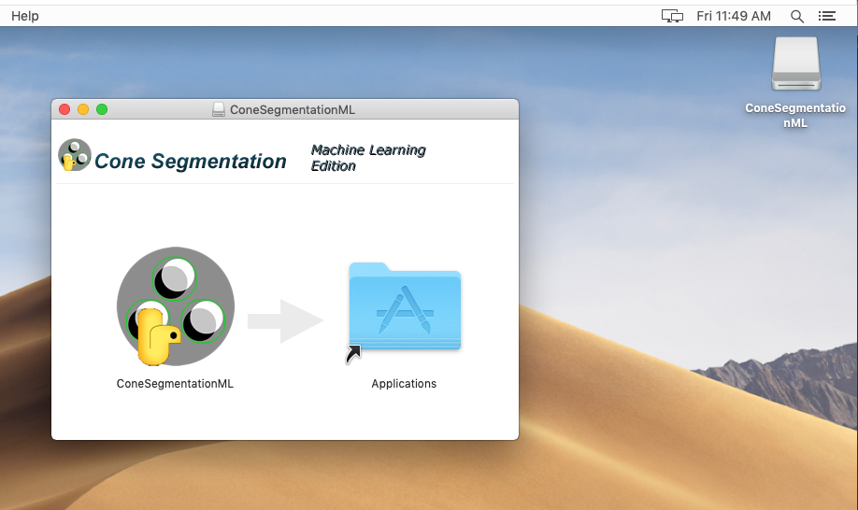
You can run the app by double-clicking on the icon, or copying it to your Applications folder by dragging the icon over "Applications". Once ConeSegmentationML is in your Applications folder, you can eject the ConeSegmentationML disk, and delete the .dmg file.
3. Once installed, double click on the software icon to open the software.
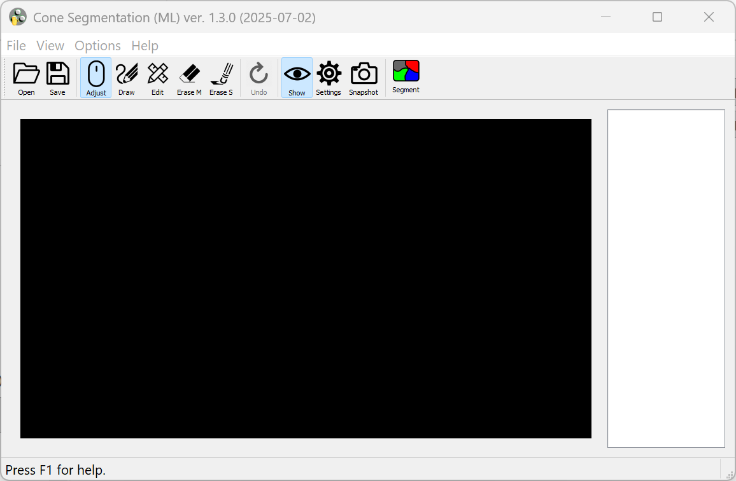
4. Click on the Open button, to load the input cone image.
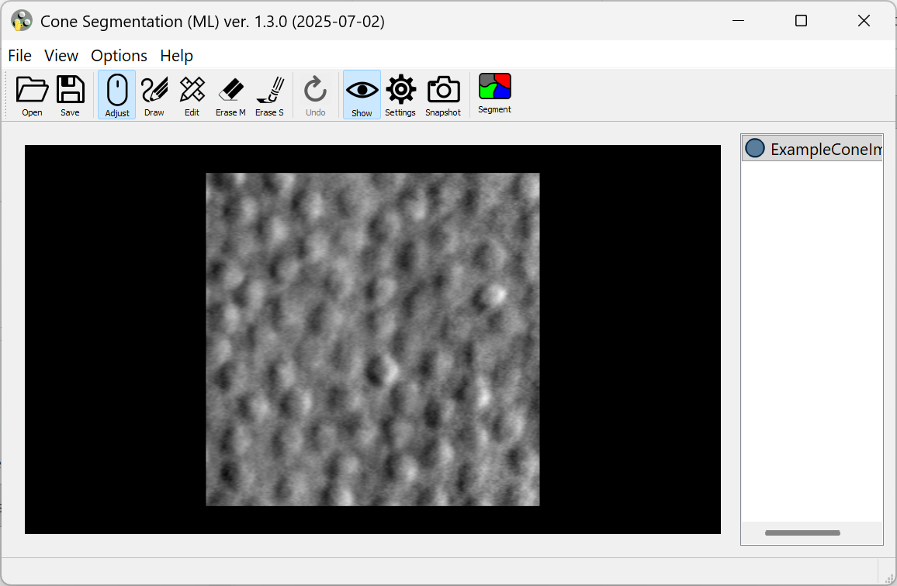
5. Then click on the Segment button to automatically detect the cones.
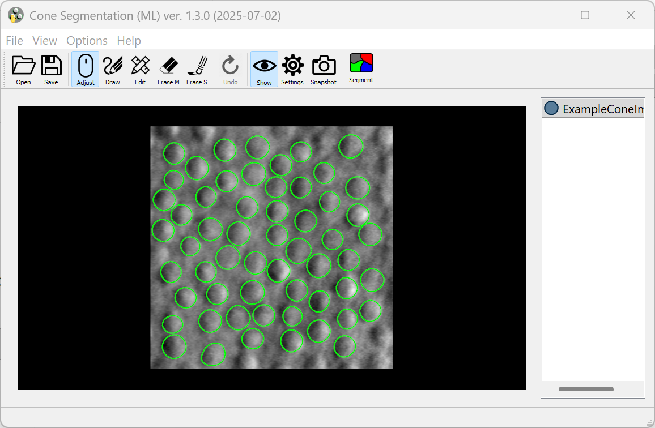
6. The Mark, Erase S, Erase M and Undo buttons allow to add annotations, erase single/multiple annotations and undo past operation.
7. The Settings tab provides options to display the centroids of the cones and also highlight the individual cone regions along with the contours.
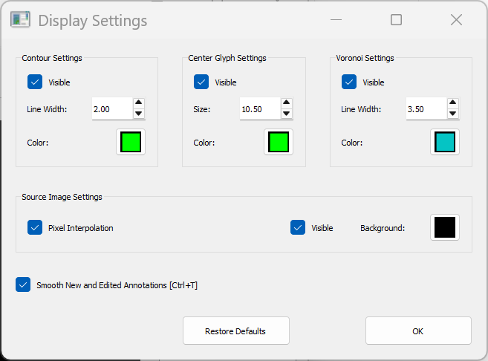
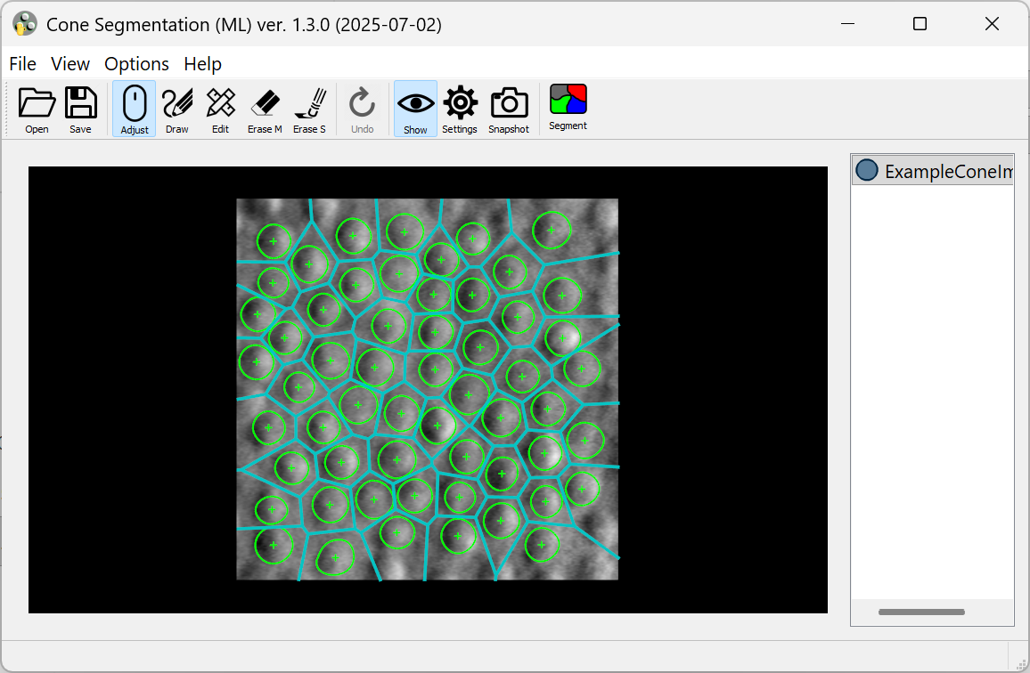
8. The Save button saves the .csv file which contains a sequence of (x, y) coordinate pairs that trace the closed contour of the individual cones.
9. The Help button provides more documentation about the software features including a table of keyboard shortcuts for common actions.
Option 2: Install Dependencies and Run from Source
Setting up development environment
- Download and install Miniconda or Anaconda.
- Check out ConeSegmentationML to a local directory `<prefix>/ConeSegementationML`. (Replace `<prefix>` with any suitable local directory).
- Run Anaconda Prompt (or Terminal), cd to `<prefix>/ConeSegmentationML`.
- Create Conda Virtual Environment (do this once, next time skip to the next step):
conda env create --file conda-environment-win.yml (Windows)
conda env create --file conda-environment-mac.yml (MAC OS)
- Activate the Virtual Environment:
conda activate ConeSegmentation
- Start the application:
python __main__.py
- Build "frozen Python" application:
pyinstaller --clean --noconfirm build-dir.spec
If successful, the result is the directory `ConeSegmentationML` inside `<prefix>/ConeSegmentationML/dist/`. You can copy this directory with all its contents to a different machine, and run the executable `__main__` (in MacOS and Linux) or `__main__.exe` (in Windows). It does not need Conda VEs or other development tools.
In MacOS systems, you can build a Mac application instead:
pyinstaller --clean --noconfirm build-app-dir.spec
The result is `<prefix>/ConeSegmentationML/dist/ConeSegmentationML.app`.
Creating Windows installer using NSIS
- Download and install NSIS (https://nsis.sourceforge.io/Download) if you don't have it already.
- Follow steps 1 through 7 of Setting up development environment to build the directory containing "frozen Python" application.
- Open Command Prompt (or Conda Prompt), cd to `<prefix>/ConeSegmentationML`.
- Run NSIS:
"C:\Program Files (x86)\NSIS\makensis.exe" /V4 build-win64-installer.nsi
(Replace “C:\Program Files (x86)\NSIS” with the actual installation directory, if different from default).
If successful, the result is `<prefix>/ConeSegmentationML/dist/ConeSegmentationML-{version}-win64.exe`. This is a regular Windows installer, which can be distributed to other Windows systems. It requires admin access.

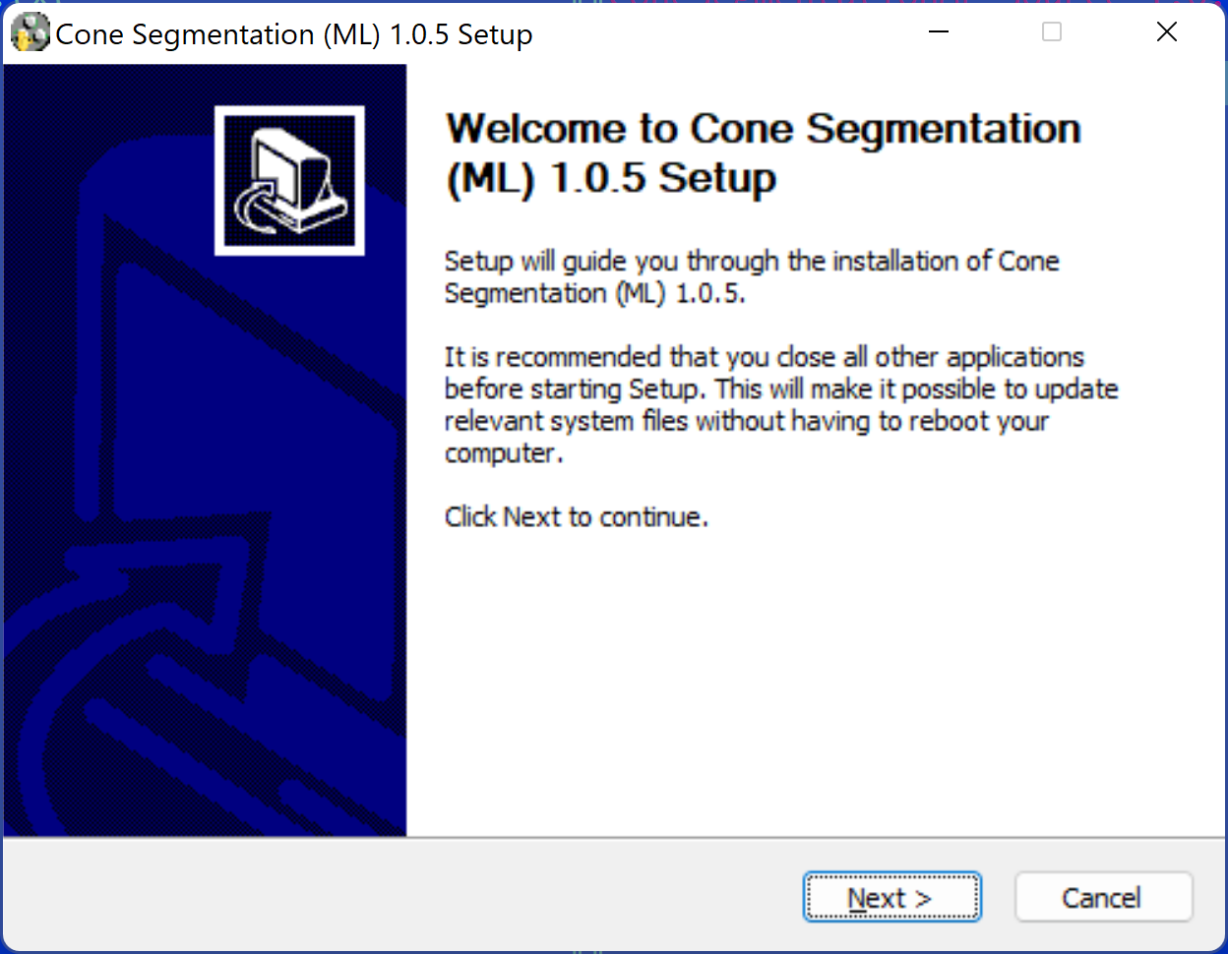

Creating MAC OS installer (.dmg)
- Make sure Xcode is installed (normally, via Apple App Store).
- Install Node.js, npm and dmg-license (require admin/sudo access), if they are not already installed:
curl -L https://raw.githubusercontent.com/tj/n/master/bin/n -o n
sudo bash n lts
sudo npm install --global minimist
sudo npm install --global dmg-license
rm n
- Follow steps 1 through 5 of Setting up development environment to setup the development environment.
- At the Conda prompt with ConeSegmentation activated, cd to `<prefix>/ConeSegmentationML` and type the command:
bash make_dmg.sh
- If prompted to allow Terminal to run Finder scripts, answer "Allow". The result is <prefix>/ConeSegmentationML/dist/ConeSegmentationML-{version}-Darwin.dmg. It is a Mac OS disk image file; when opened, it asks for accepting the license agreement, then mounts itself as an external drive and opens a Finder window, that looks like this:
- You can run the app by double-clicking on the icon, or copy it to your Applications folder by dragging the icon over "Applications". Once ConeSegmentationML is in your Applications folder, you can eject the ConeSegmentationML disk, and delete ConeSegmentationML-Darwin.dmg.
Deleting Conda Virtual Environment
To delete the Virtual environment at the Conda prompt, deactivate it first if it is active
conda deactivate
then type:
conda remove --name ConeSegmentation

