Readme
RPE Detection is a software package for identifying retinal pigment epithelial (RPE) cells in adaptive optics images.
If any portion of this code is used, please cite the following paper in your publication:
Jianfei Liu, Yoo-Jean Han, Tao Liu, Nancy Aguilera and Johnny Tam, "Spatially aware dense-linkNet based regression improves fluorescent cell detection in adaptive optics ophthalmic images." IEEE journal of biomedical and health informatics 24.12 (2020): 3520-3528.
Getting Started
There are two ways to use the software:
- Option 1: Run using prebuilt executables (No installation required)
- Option 2: Install Dependencies and Run from Source System Requirements
Option 1: Run using prebuilt executables
1. Download the executable file (.exe for Windows or .dmg for Mac OS) from the Releases section with the Latest tag.
2. On Windows systems, installation can be completed by double-clicking the .exe file and following the on-screen prompts. For Mac OS, the .dmg is a Mac OS disk image file. When opened, it asks for accepting the license agreement, then mounts itself as an external drive and opens a Finder window, that looks like this:
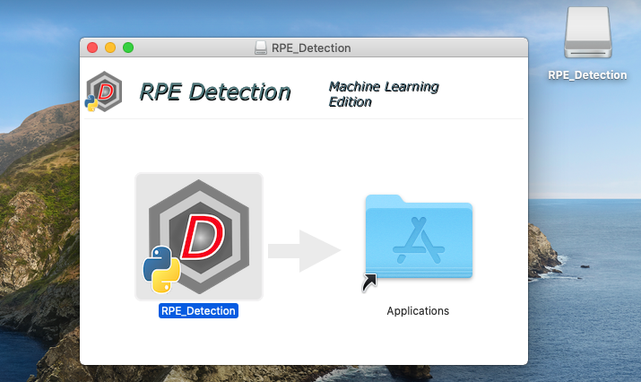
You can run the app by double-clicking on the icon, or copying it to your Applications folder by dragging the icon over "Applications". Once RPE_Detection is in your Applications folder, you can eject the RPE_Detection disk, and delete the .dmg file.
3. Once installed, double click on the software icon to open the software.
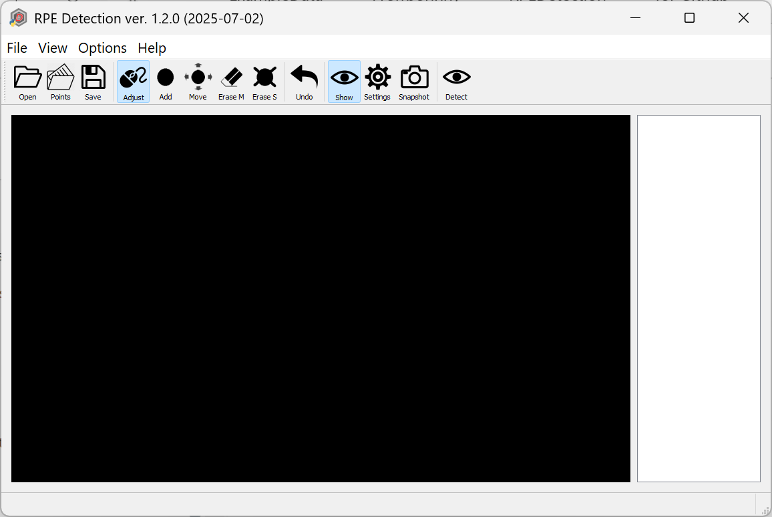
4. Click on the Open button, to load the input RPE image.
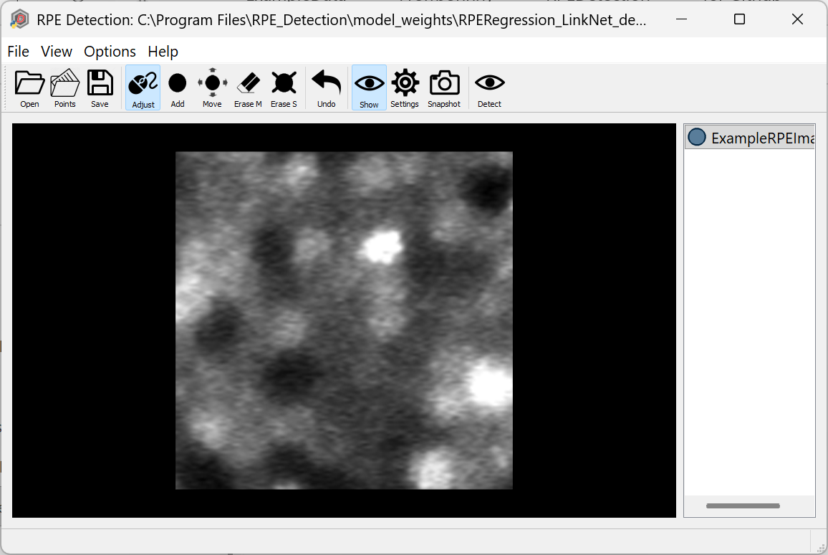
5. Then click on the Detect button to automatically detect the RPE cells.
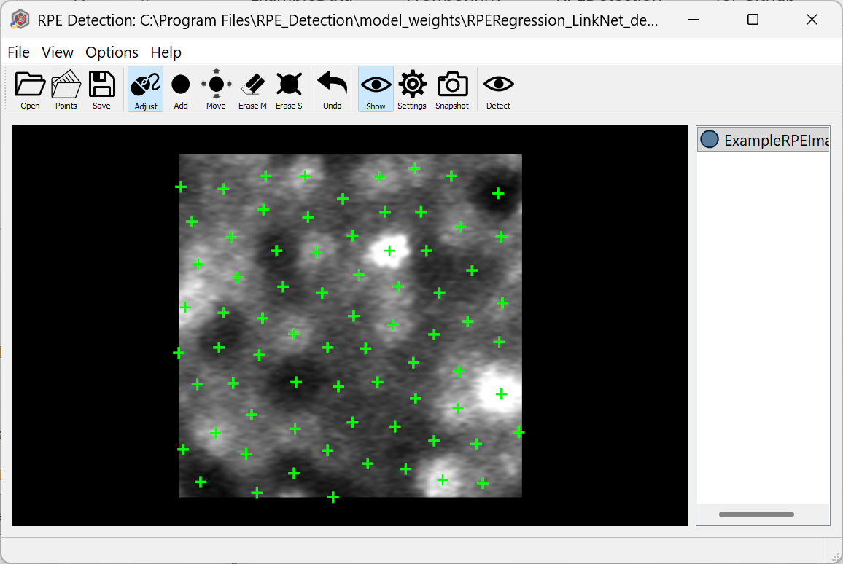
6. The Mark, Erase S, Erase M and Undo buttons allow to add annotations, erase single/multiple annotations and undo past operation.
7. The Settings tab provides options to display the centroids of the cones and also highlight the individual cone regions along with the contours.
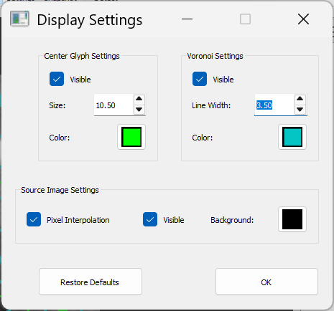
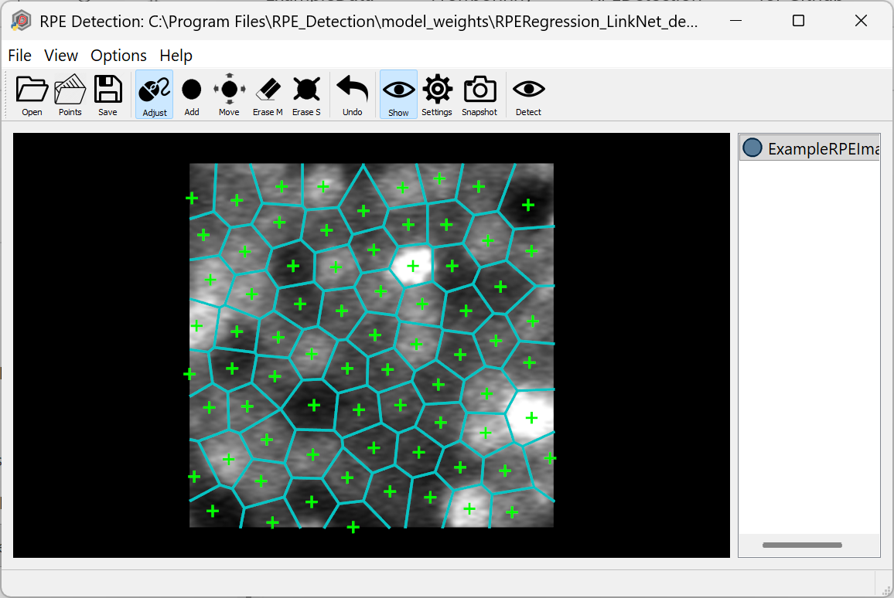
8. The Save button saves the .csv file with the (x,y) coordinates of the RPE cell centroids in the location of the input image.
9. The Help button provides more documentation about the software features including a table of keyboard shortcuts for common actions.
Option 2: Install Dependencies and Run from Source
Setting up development environment
- Download and install Miniconda or Anaconda.
- Check out RPE_Detection to a local directory <prefix>/RPE_Detection. (Replace <prefix> with any suitable local directory).
- Run Anaconda Prompt (or Terminal), cd to <prefix>/RPE_Detection.
- Create Conda Virtual Environment (do this once, next time skip to the next step):
conda env create --file conda-environment-win.yml (Windows)
conda env create --file conda-environment-mac.yml (Mac OS)
- Activate the Virtual Environment:
conda activate RPE_Detection
- Start the application:
python __main__.py
- Build "frozen Python" application:
pyinstaller --clean --noconfirm build-dir.spec
If successful, the result is the directory RPE_Detection inside <prefix>/RPE_Detection/dist/. You can copy this directory with all its contents to a different machine, and run the executable __main__ (in MacOS and Linux) or __main__.exe (in Windows). It does not need Conda VEs or other development tools.
In MacOS systems, you can build a Mac application instead:
pyinstaller --clean --noconfirm build-app-dir.spec
The result is <prefix>/RPE_Detection/dist/RPE_Detection.app.
Creating Windows installer using NSIS
- Download and install NSIS if you don't have it already.
- Follow steps 1 through 7 of Setting up development environment to build the directory containing "frozen Python" application.
- Open Command Prompt (or Conda Prompt), cd to <prefix>/RPE_Detection.
- Run NSIS:
"C:\Program Files (x86)\NSIS\makensis.exe" /V4 build-win64-installer.nsi
(Replace C:\Program Files (x86)\NSIS with the actual installation directory, if different from default). If successful, the result is <prefix>/ RPE_Detection /dist/ RPE_Detection-{version}-win64.exe. This is a regular Windows installer, which can be distributed to other Windows systems. It requires admin access.

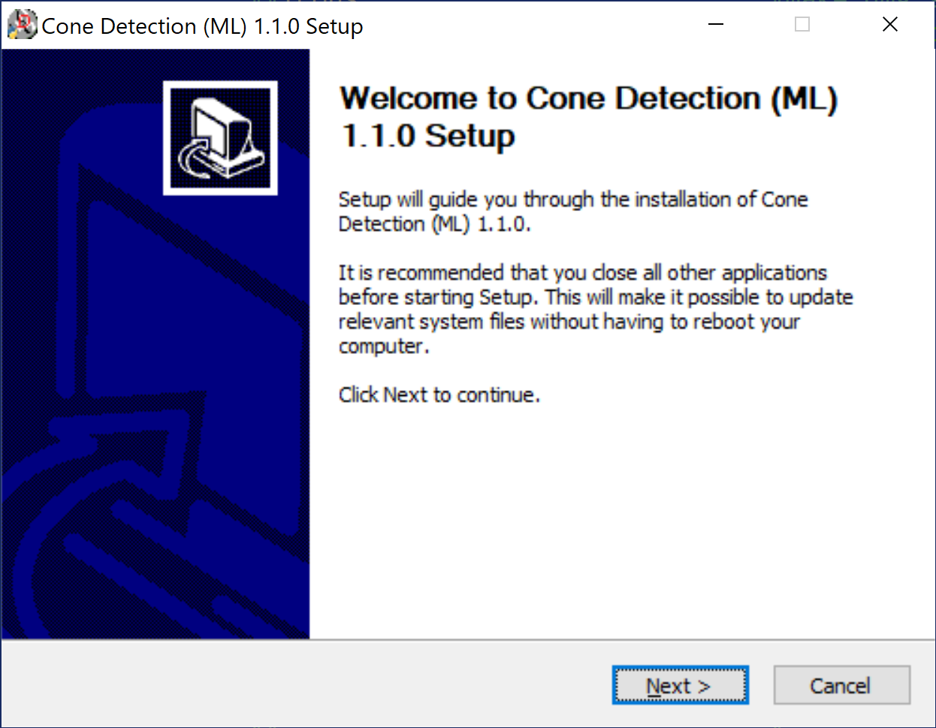

Creating MAC OS installer (.dmg)
- Make sure Xcode is installed (normally, via Apple App Store).
- Install Node.js, npm and dmg-license (require admin/sudo access), if they are not already installed:
curl -L https://raw.githubusercontent.com/tj/n/master/bin/n -o n
sudo bash n lts
sudo npm install --global minimist
sudo npm install --global dmg-license
rm n
- Follow steps 1 through 5 of Setting up development environment to setup the development environment.
- At the Conda prompt with RPE_Detection activated, cd to <prefix>/ RPE_Detection and type the command:
bash make_dmg.sh
If prompted to allow Terminal to run Finder scripts, answer "Allow". The result is <prefix>/ RPE_Detection /dist/ RPE_Detection-{version}-Darwin.dmg. It is a Mac OS disk image file; when opened, it asks for accepting the license agreement, then mounts itself as an external drive and opens a Finder window, that looks like this:

You can run the app by double-clicking on the icon, or copy it to your Applications folder by dragging the icon over "Applications". Once RPE_Detection is in your Applications folder, you can eject the RPE_Detection disk, and delete RPE_Detection-{version}-Darwin.dmg.

Deleting Conda Virtual Environment
To delete the Virtual environment at the Conda prompt, deactivate it first if it is active:
conda deactivate
then type:
conda remove --name RPE_Detection

